**To Enable S3 Intelligent- Tiering Archive Access and Deep Archive Access tiers :**

ANSWER:

**Step 1 : Go to Google and search AWS.**

**Step 2 : Login to your account.**

**Step 3 : Go to search box S3 service.**

**Step 4 : click select our bucket and go to properties.**

**Step 5 : Choose intelligent tiering archive configuration and fill the details.**

**Step 6 : Create configuration.**

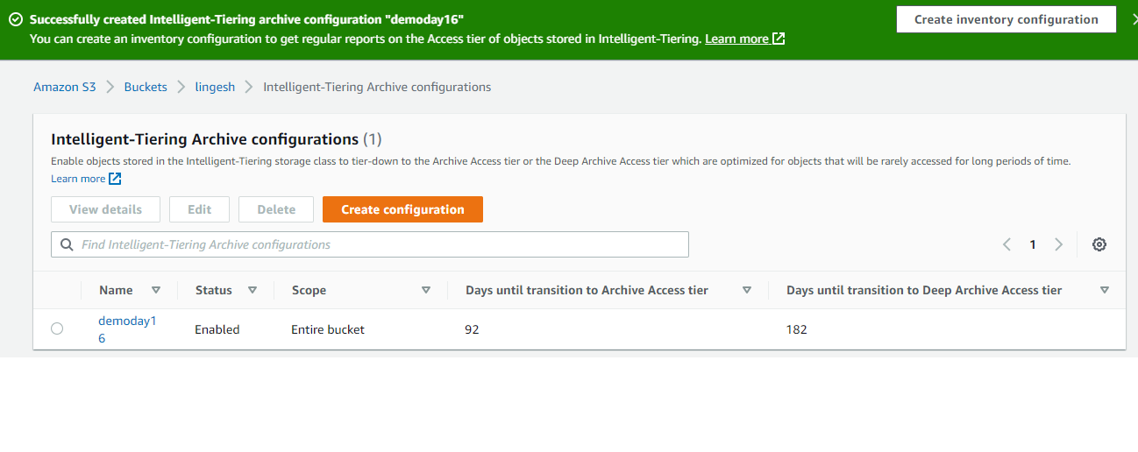

**Q2: How to restore objects from the S3 Intelligent-Tiering Archive Access and Deep Archive Access tiers**

**ANSWER :**

**Step 1 : Login to AWS management Account.**

**Step 2 : Search s3 services in search box**

**Step 3 : Select the previous bucket.**

**Step 4 : Click the Action option to select the initiate restore.**

**Step 5 : Here we can choose the transition to archive access tier and deep archive access tier days.**